# CS 255 System Design Document Template

This template lays out all the different sections that you need to complete for Project Two. Each section has guidance to prompt your thinking. You will need to continually reference the interview transcript as you work to make sure that you are addressing your client’s needs. There is no required length for the final document. Instead the goal is to complete each section based on what your client’s needs are. Remove this note when you are finished, and replace all bracketed text with the relevant information.

## UML Diagrams

### UML Use Case Diagram

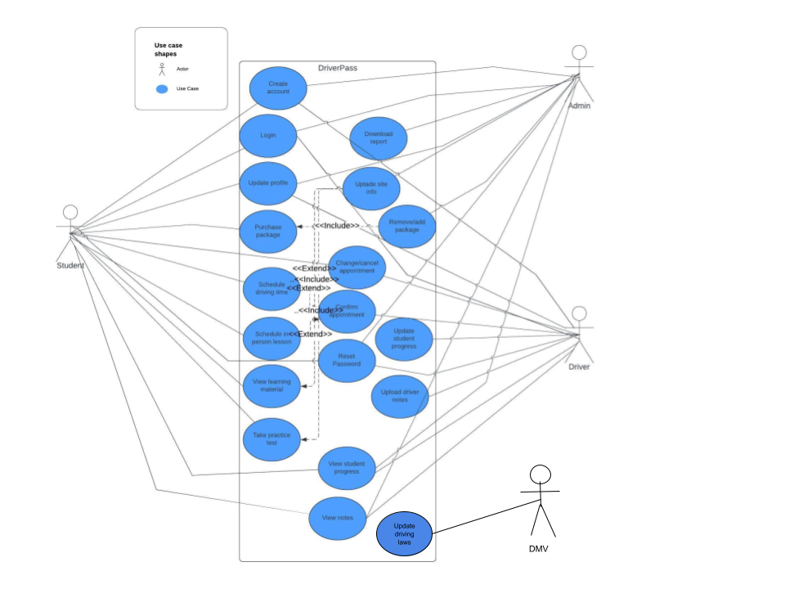

### UML Activity Diagrams

Use case: Logging in to existing DriverPass account

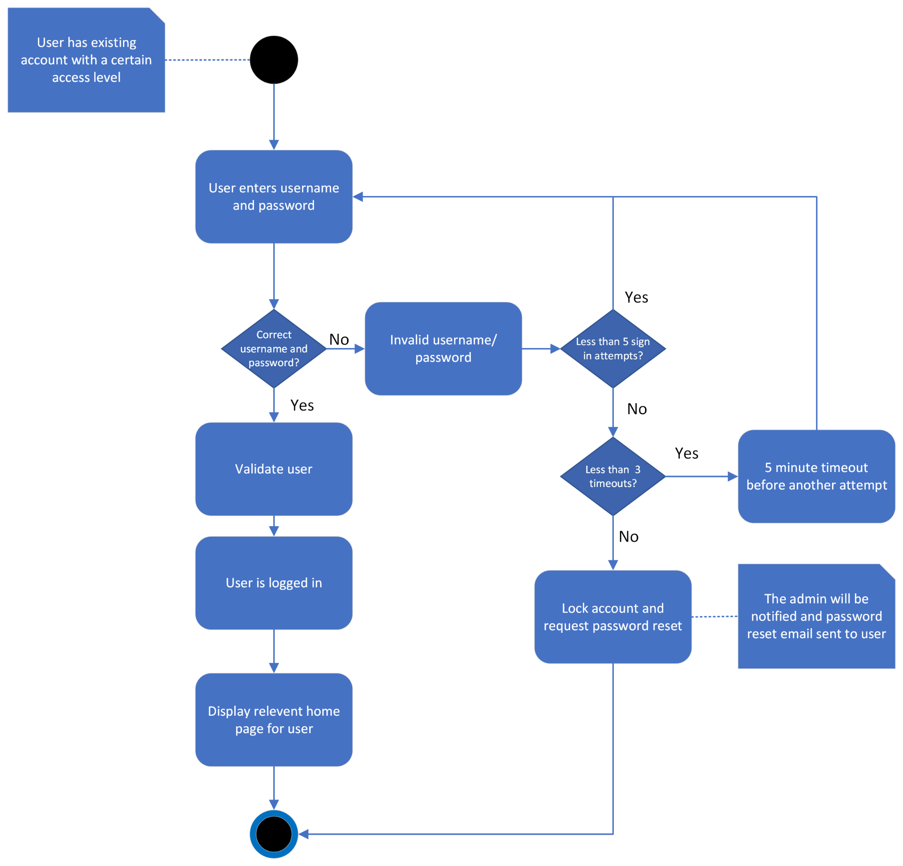

Use case: Student requesting driving time

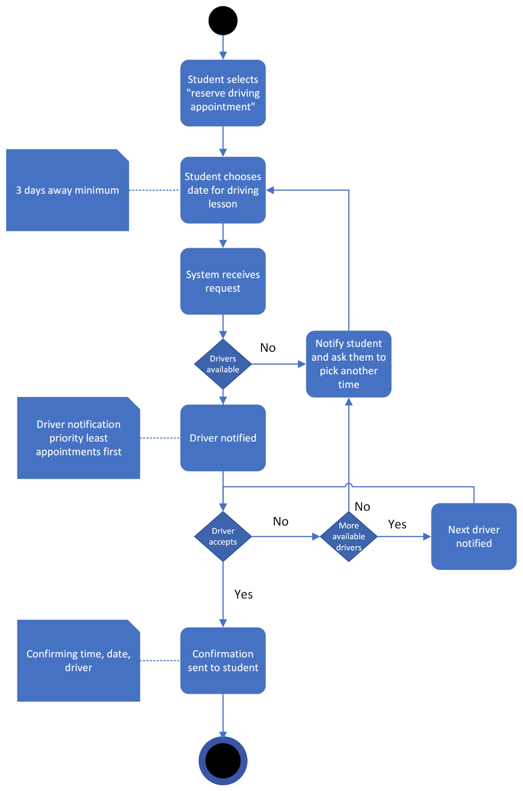

### UML Sequence Diagram

Use case: Logging in to existing DriverPass account

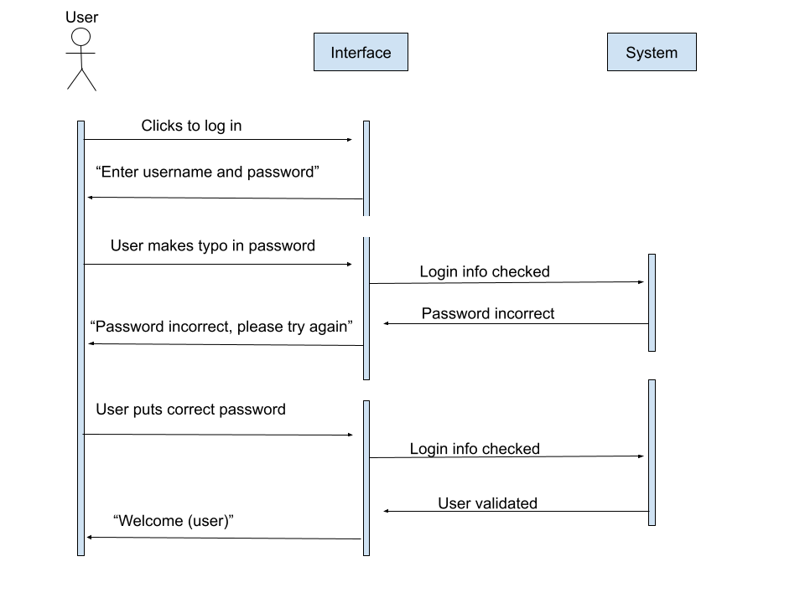

### UML Class Diagram

Empty classes would have methods

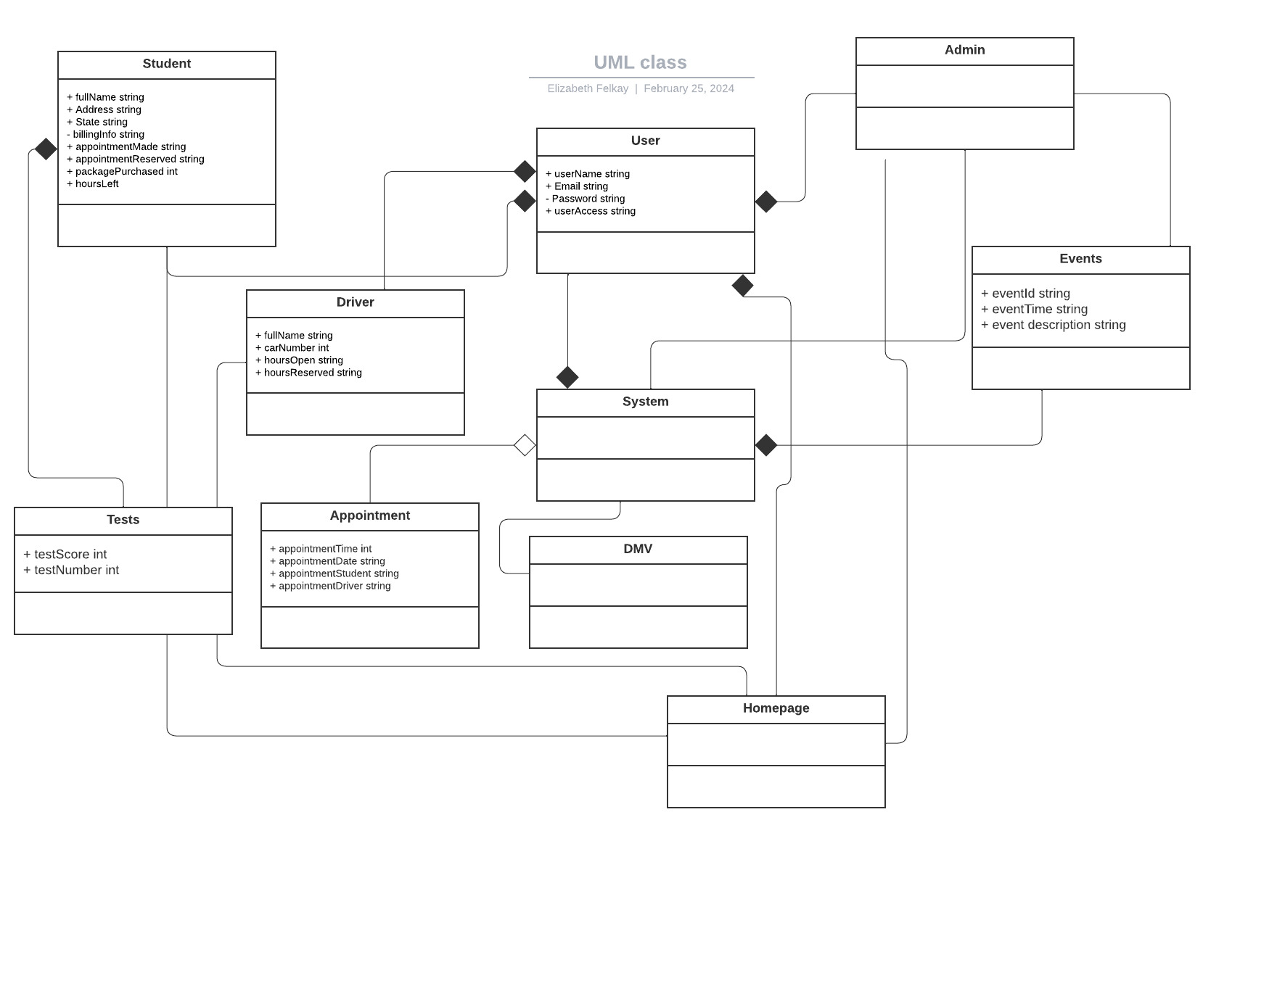

## Technical Requirements

Based on the diagrams for the DriverPass system, there are many technical requirements to address.

The hardware requirements are:

* The system shall run from a cloud server
* The system shall have enough storage and memory that it stays efficient

The software requirements are:

* The system shall be developed in linux
* The system shall use an object oriented language
* The system shall maintain a database of each student and driver
* The system shall be accessed via web browser
* The system shall be able to integrate with other systems

The tools required are:

* The system shall use a monitoring tool
* The system shall use a debugging tool

The infrastructure requirements are:

* The system shall be scalable
* The system shall have backup and recovery systems
* The system shall be always available

Misc:

* The system shall validate user credentials when logging in.
* The system shall distinguish the type of user: student, driver, admin, or boss.
* The system shall allow users to reset password if needed.
* The system shall allow 5 failed login attempts before a timeout.
* The system shall block the user and notify admin if 3 timeouts have occurred.
* The system shall create user account with user information.
* The system shall allow access from anywhere online.
* The system shall display types of packages for customers to choose from.
* The system shall allow customers to select a package to purchase.
* The system shall allow admin to disable packages that are full.
* The system shall track which user is matched up with a certain driver, time, and car.
* The system shall display customer information, hours left, and status.
* The system shall display drivers notes.
* The system shall display lesson time, start hour, end hour.
* The system shall display driver and student photos.
* The system shall allow valid students access to online learning tools.
* The system shall connect with DMV to be updated with new information.
* The system shall display test results.